**PAPER – II                 PRACTICAL NO. : 08**

**AIM : OSPF IMPLEMENTATION**

1. **IMPLEMENT SINGLE-AREA OSPFv2**
2. **IMPLEMENT MULTI-AREA OSPFv2**
3. **OSPFv2 ROUTE SUMMARIZATION AND FILTERING**
4. **IMPLEMENT MULTIAREA OSPFv3**

**ROLL NO. : 02                                BATCH : M.SC PART-I**

**DATE : 17/12/22**

**CODE AND OUTPUT :**

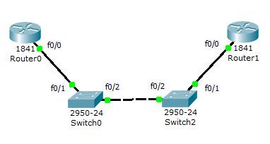

Router0 :

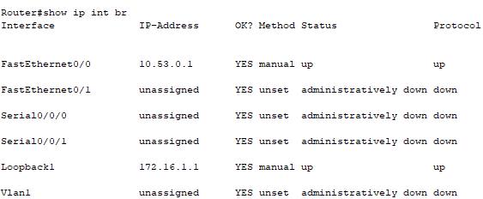

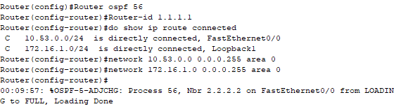

Router1 :

